**DAILY ONLINE ACTIVITIES SUMMARY**

|  |  |  |  |  |  |  |  |  |
| --- | --- | --- | --- | --- | --- | --- | --- | --- |
| **Date:** | **28-06-2020** | | | | | **Name:** | **IJAZ IBRAHIM** | |
| **Sem & Sec** | **4th A** | | | | | **USN:** | **4AL18CS026** | |
| **Online Test Summary** | | | | | | | | |
| **Subject** | | | **N/A** | | | | | |
| **Max. Marks** | | | **N/A** | **Score** | | | **N/A** | |
| **Certification Course Summary** | | | | | | | | |
| **Course** | **Python Programming for Beginners in Data Science** | | | | | | | |
| **Certificate Provider** | | **Udemy** | | | **Duration** | | | **14 hours** |
| **Coding Challenges** | | | | | | | | |
| **Problem Statement: 1 C++ program.** | | | | | | | | |
| **Status: Executed** | | | | | | | | |
| **Uploaded the report in Github** | | | | | **Yes** | | | |
| **If yes Repository name** | | | | | **https://github.com/ijazibrahim/DailyReport.git** | | | |
| **Uploaded the report in slack** | | | | | **Yes** | | | |

Online Test Details: (Attach the snapshot and briefly write the report for the same)

No online examination was conducted today.

Certification Course Details: (Attach the snapshot and briefly write the report for the same)

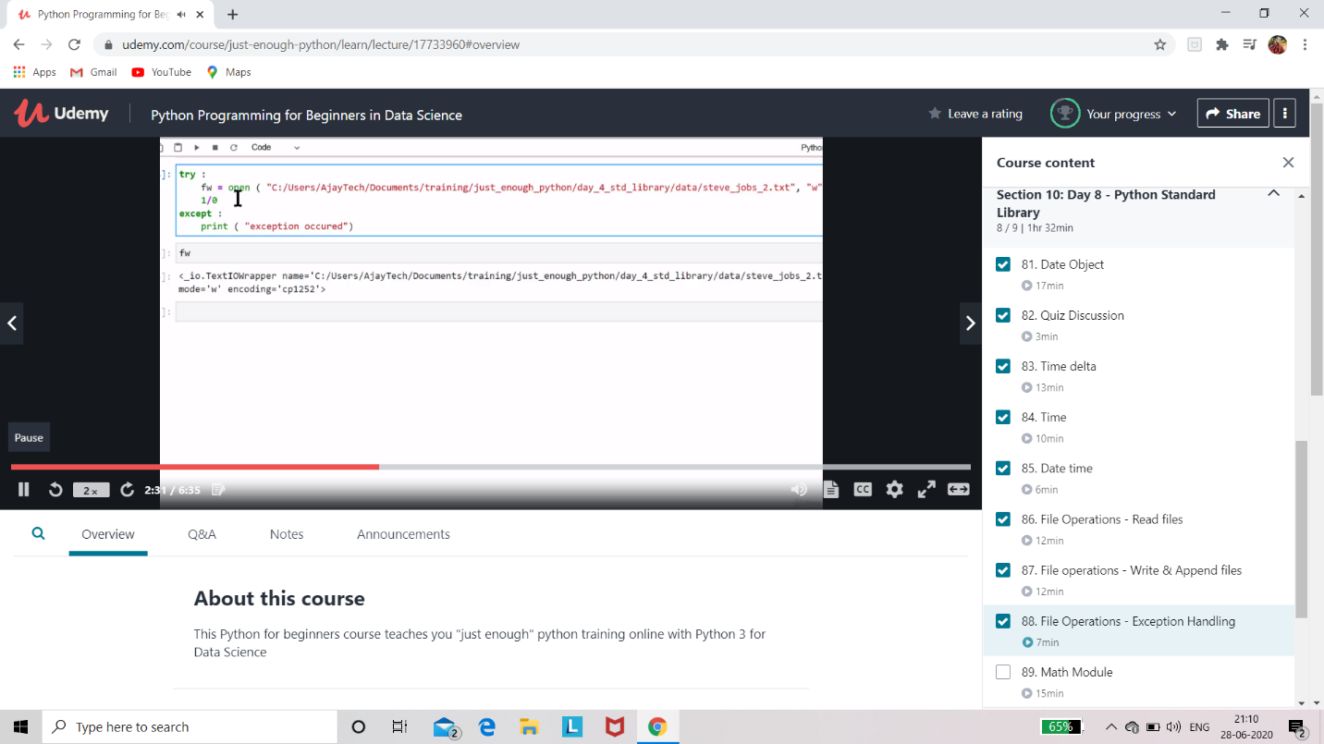

I have Completed 12.5 hour of the course out of 14 hours and uploaded it in Github repository.

Coding Challenges Details: (Attach the snapshot and briefly write the report for the same)

Program 1:

